Test Case: tc005_SPX_Dev5_Crear_Requisicion_Spot_Con_FAD_Tipo_Cobro_Project
Step 1 - Enter username and password and click to button Enter: Credentials Entered
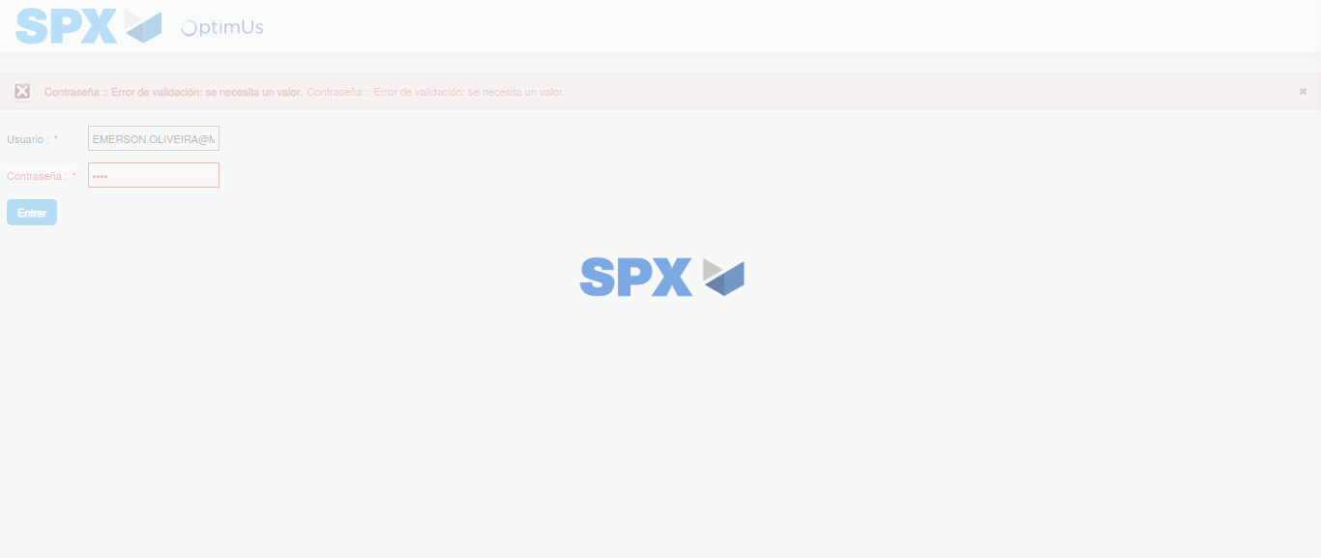Image file-name: QC_Testing-tc005_SPX_Dev5_Crear_Requisicion_Spot_Con_FAD_Tipo_Cobro_Project-1785974981770

Step 2 - Select to UEN and Access to Spot Buy Requisitions : UEN Correctly selected and Correct access
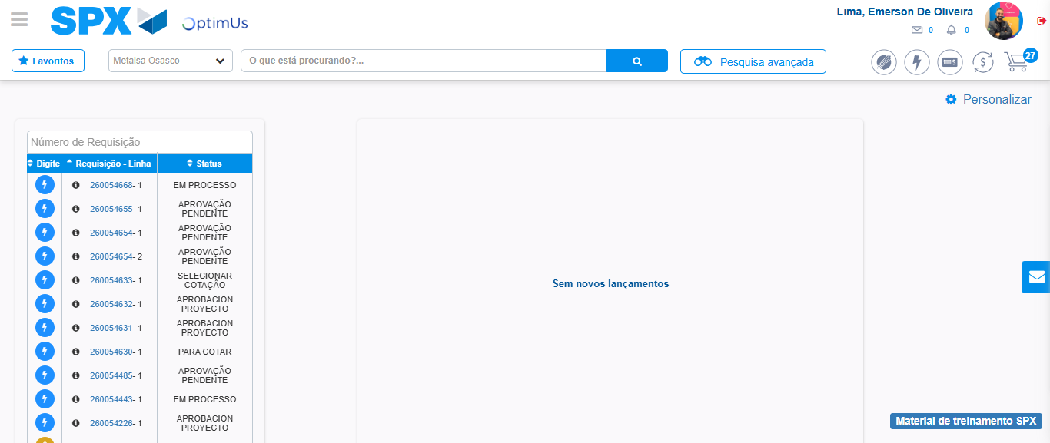Image file-name: QC_Testing-tc005_SPX_Dev5_Crear_Requisicion_Spot_Con_FAD_Tipo_Cobro_Project-1785975006773

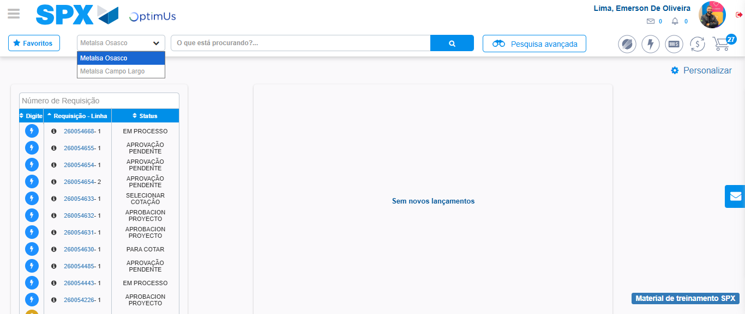Image file-name: QC_Testing-tc005_SPX_Dev5_Crear_Requisicion_Spot_Con_FAD_Tipo_Cobro_Project-1785975009218

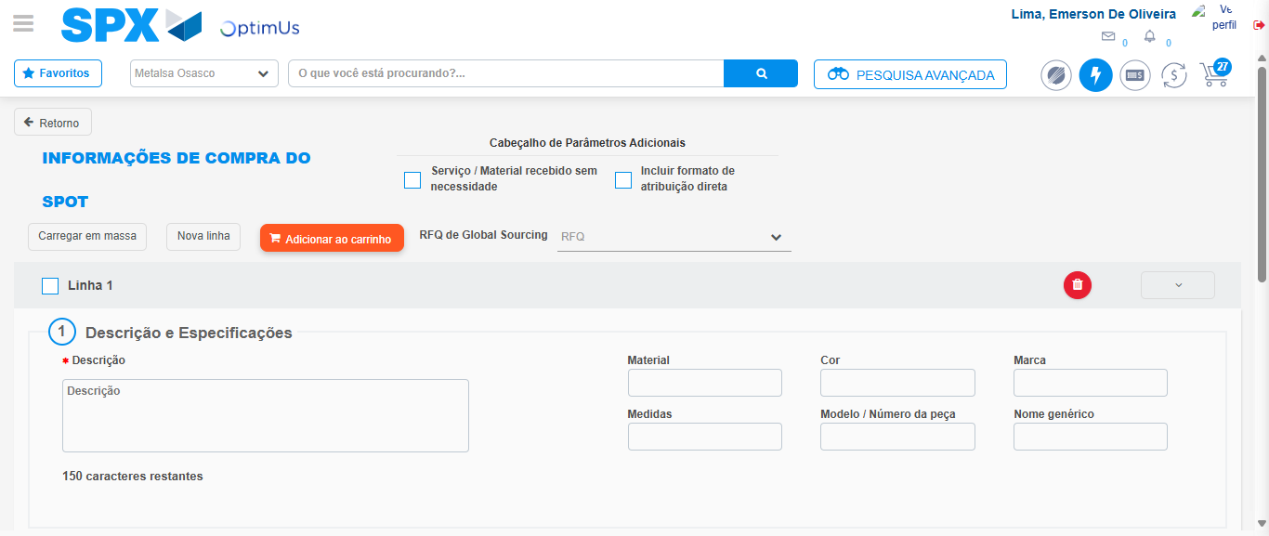Image file-name: QC_Testing-tc005_SPX_Dev5_Crear_Requisicion_Spot_Con_FAD_Tipo_Cobro_Project-1785975013299

Step 3 - Add FAD to Requisition: FAD Successfully Added
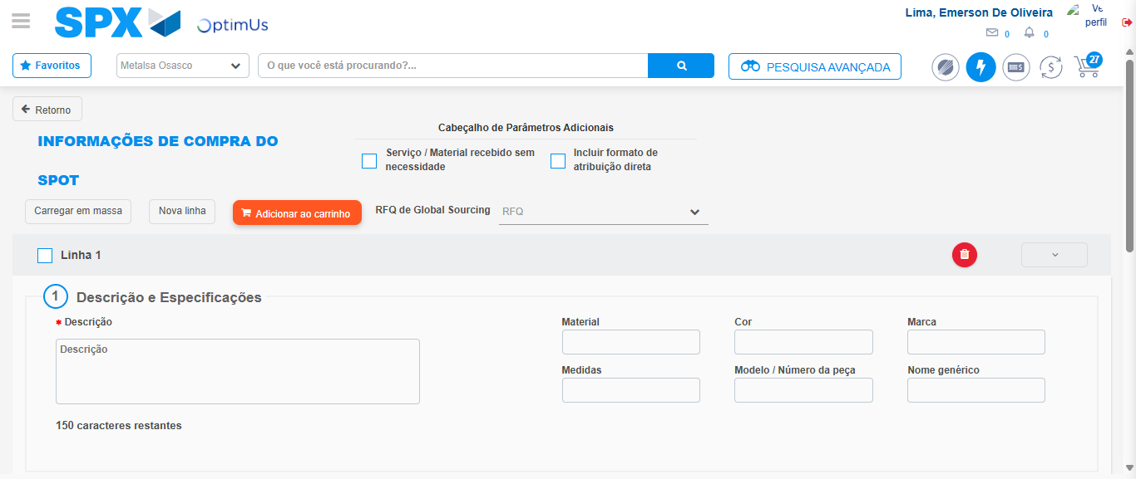Image file-name: QC_Testing-tc005_SPX_Dev5_Crear_Requisicion_Spot_Con_FAD_Tipo_Cobro_Project-1785975013561

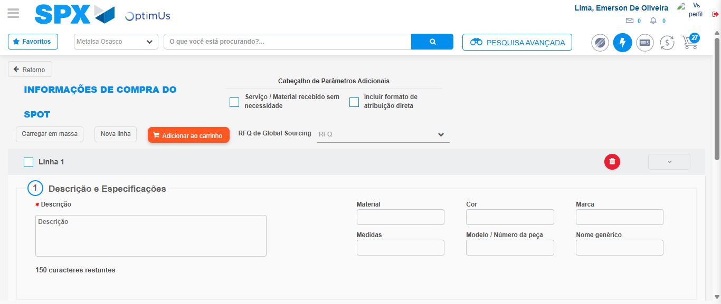Image file-name: QC_Testing-tc005_SPX_Dev5_Crear_Requisicion_Spot_Con_FAD_Tipo_Cobro_Project-1785975013797

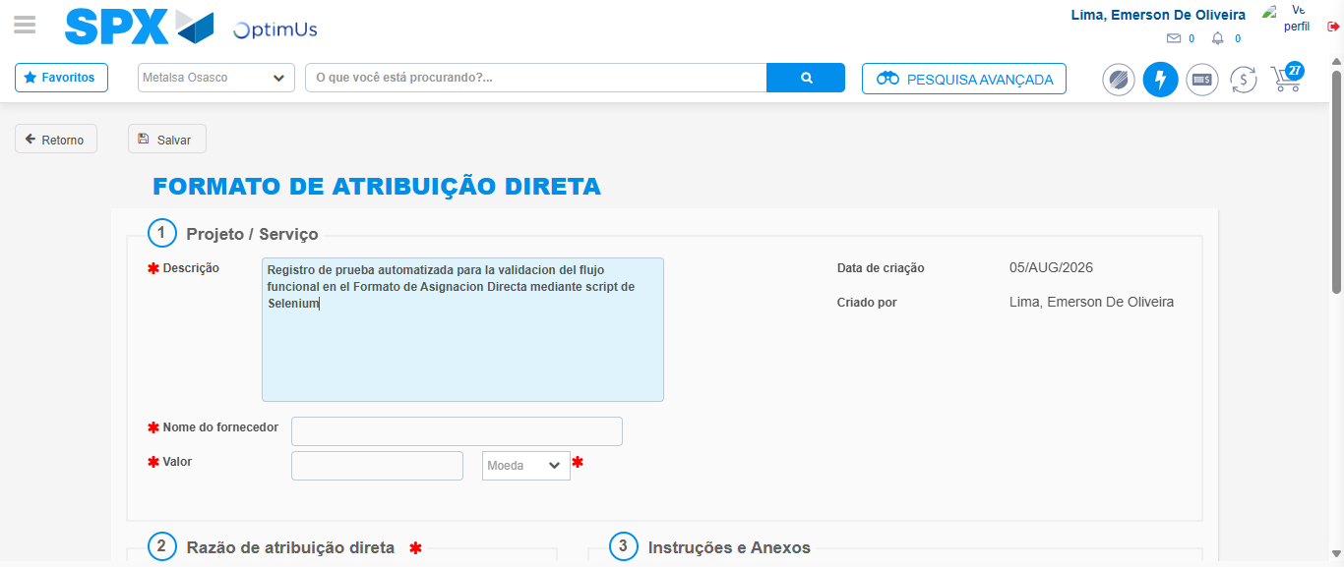Image file-name: QC_Testing-tc005_SPX_Dev5_Crear_Requisicion_Spot_Con_FAD_Tipo_Cobro_Project-1785975016514

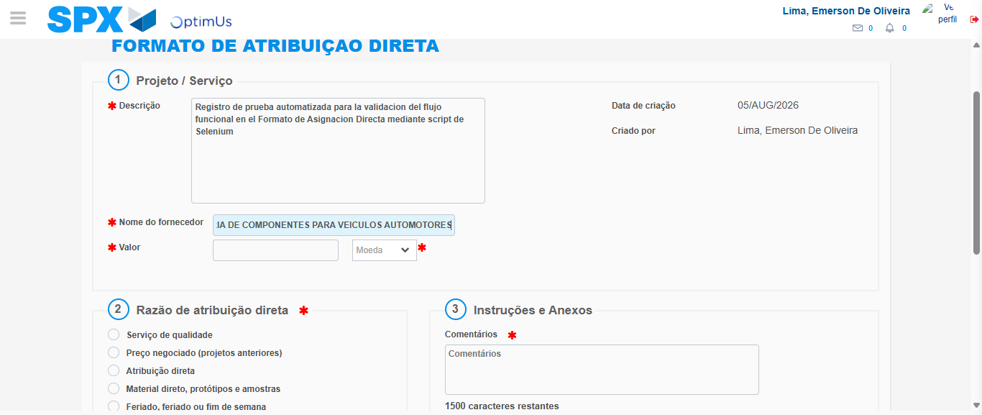Image file-name: QC_Testing-tc005_SPX_Dev5_Crear_Requisicion_Spot_Con_FAD_Tipo_Cobro_Project-1785975024890

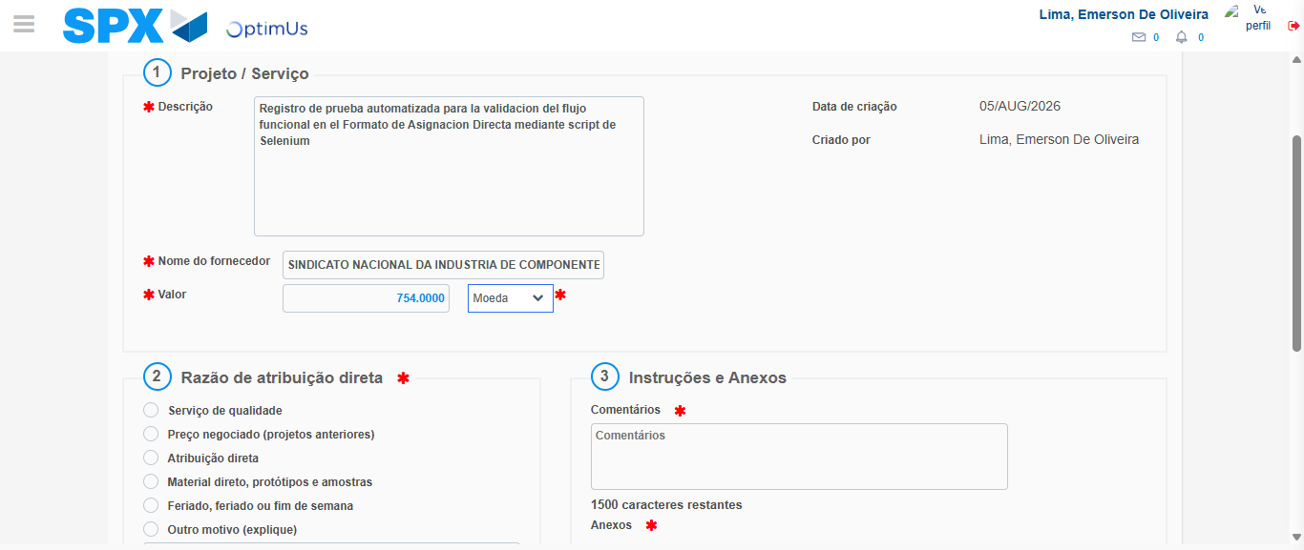Image file-name: QC_Testing-tc005_SPX_Dev5_Crear_Requisicion_Spot_Con_FAD_Tipo_Cobro_Project-1785975025257

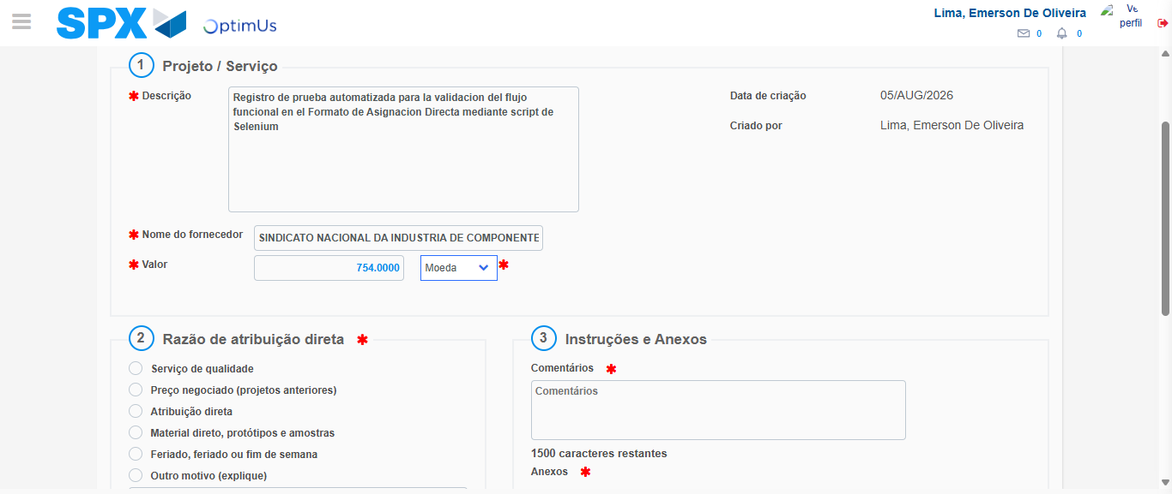Image file-name: QC_Testing-tc005_SPX_Dev5_Crear_Requisicion_Spot_Con_FAD_Tipo_Cobro_Project-1785975025450

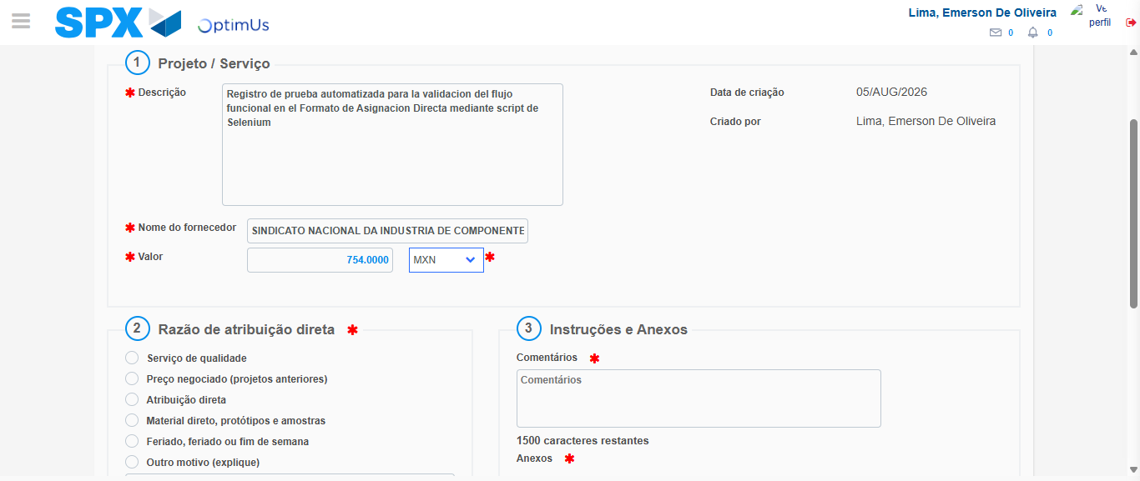Image file-name: QC_Testing-tc005_SPX_Dev5_Crear_Requisicion_Spot_Con_FAD_Tipo_Cobro_Project-1785975025778

Image file-name: QC_Testing-tc005_SPX_Dev5_Crear_Requisicion_Spot_Con_FAD_Tipo_Cobro_Project-1785975025949

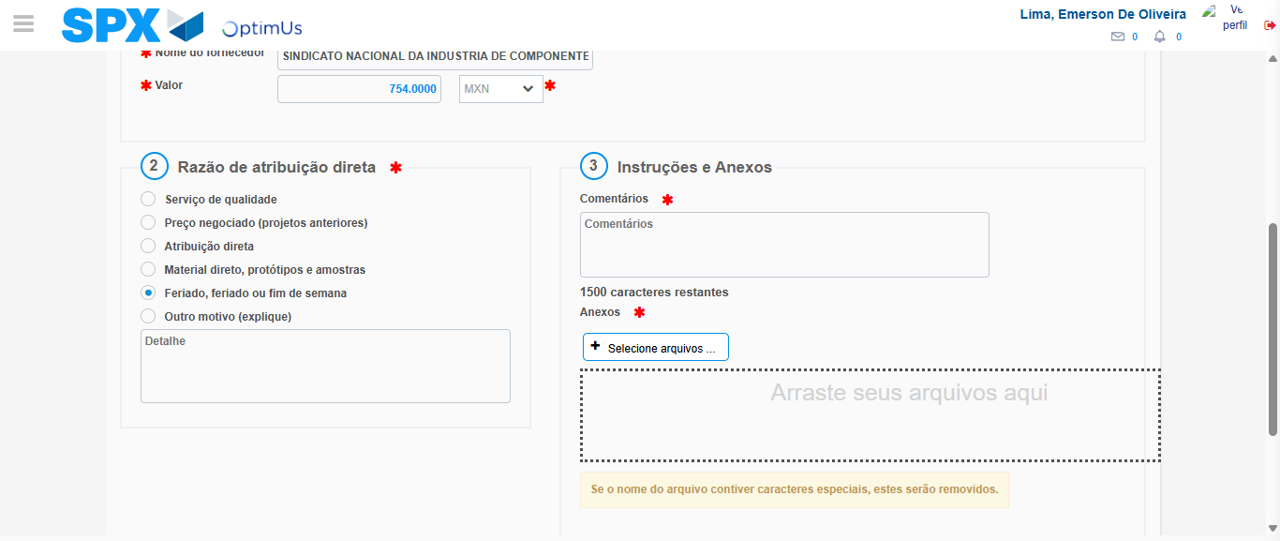Image file-name: QC_Testing-tc005_SPX_Dev5_Crear_Requisicion_Spot_Con_FAD_Tipo_Cobro_Project-1785975026757

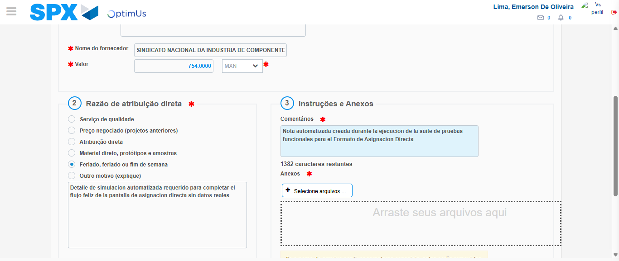Image file-name: QC_Testing-tc005_SPX_Dev5_Crear_Requisicion_Spot_Con_FAD_Tipo_Cobro_Project-1785975037674

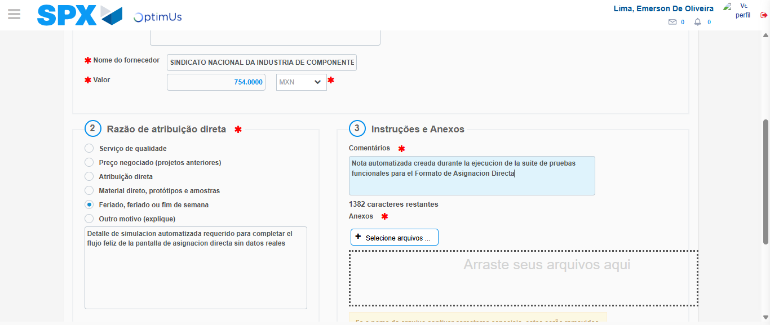Image file-name: QC_Testing-tc005_SPX_Dev5_Crear_Requisicion_Spot_Con_FAD_Tipo_Cobro_Project-1785975038233

Step 4 - Data Capture Spot Buy Requisition: Data captured correctly
Image file-name: QC_Testing-tc005_SPX_Dev5_Crear_Requisicion_Spot_Con_FAD_Tipo_Cobro_Project-1785975013561

Image file-name: QC_Testing-tc005_SPX_Dev5_Crear_Requisicion_Spot_Con_FAD_Tipo_Cobro_Project-1785975013797

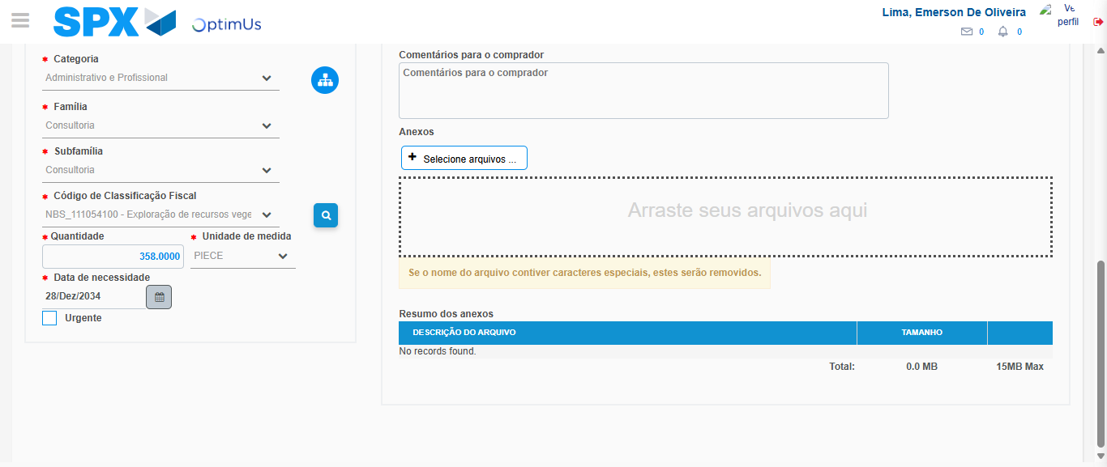Image file-name: QC_Testing-tc005_SPX_Dev5_Crear_Requisicion_Spot_Con_FAD_Tipo_Cobro_Project-1785975057066

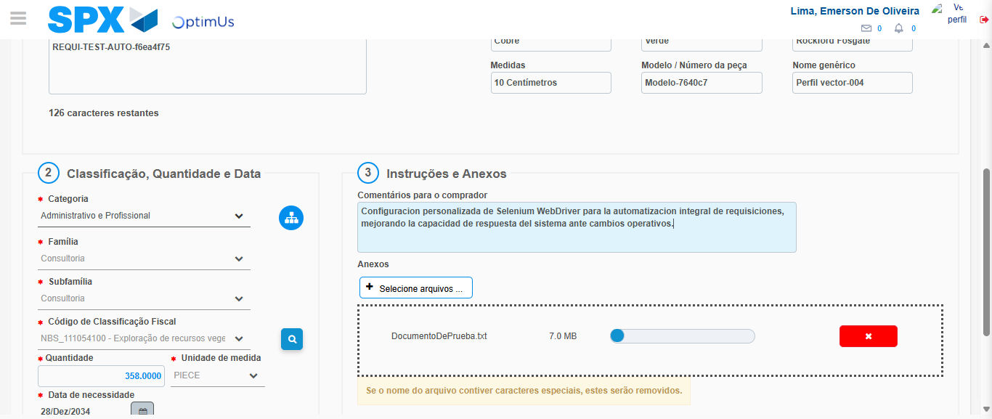Image file-name: QC_Testing-tc005_SPX_Dev5_Crear_Requisicion_Spot_Con_FAD_Tipo_Cobro_Project-1785975057799

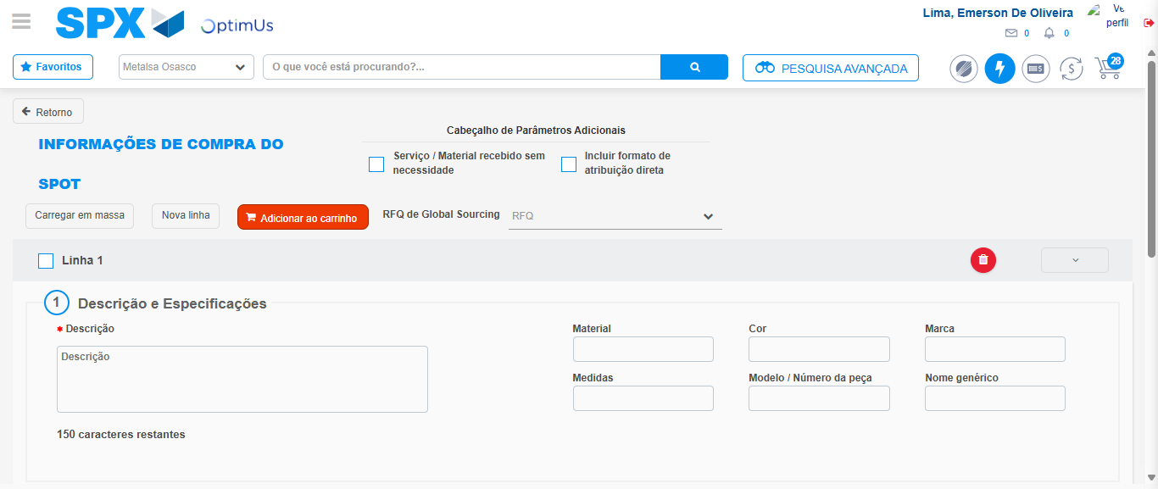Image file-name: QC_Testing-tc005_SPX_Dev5_Crear_Requisicion_Spot_Con_FAD_Tipo_Cobro_Project-1785975066693

Step 8 - Return to Main Page SPX : Return to Main Page SPX
Image file-name: QC_Testing-tc005_SPX_Dev5_Crear_Requisicion_Spot_Con_FAD_Tipo_Cobro_Project-1785975006773

Image file-name: QC_Testing-tc005_SPX_Dev5_Crear_Requisicion_Spot_Con_FAD_Tipo_Cobro_Project-1785975009218

Image file-name: QC_Testing-tc005_SPX_Dev5_Crear_Requisicion_Spot_Con_FAD_Tipo_Cobro_Project-1785975013299

Image file-name: QC_Testing-tc005_SPX_Dev5_Crear_Requisicion_Spot_Con_FAD_Tipo_Cobro_Project-1785975068866

Image file-name: QC_Testing-tc005_SPX_Dev5_Crear_Requisicion_Spot_Con_FAD_Tipo_Cobro_Project-1785975069032

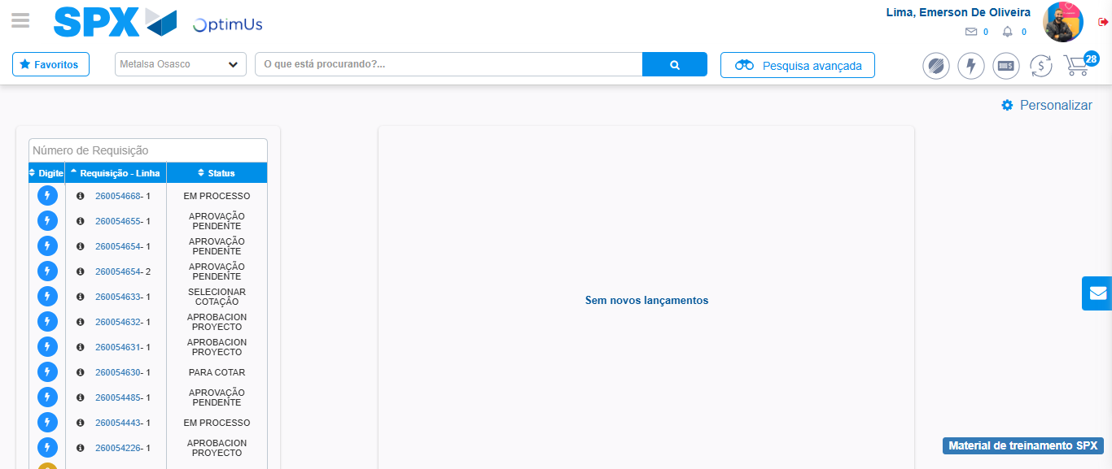Image file-name: QC_Testing-tc005_SPX_Dev5_Crear_Requisicion_Spot_Con_FAD_Tipo_Cobro_Project-1785975090072

Step 9 - Log Out : Log Out SPX
Image file-name: QC_Testing-tc005_SPX_Dev5_Crear_Requisicion_Spot_Con_FAD_Tipo_Cobro_Project-1785975090243

